Graduate Student Conference on Energy and Sustainable Development
29 December 2023, Kadir Has University Cibali Campus, Istanbul

Title

First A. Authorª, Second B. Authorª and Third C. Author^{b}

ª Authors’ Department, Institute, Country.
(E-mail: firstauthorsname@aaaa.bbb, secondauthorsname@aaaa.bbb)
^{b} Author’s Department, Institute, Country.
(E-mail: thirdauthorsname@aaaa.bbb)

A B S T R A C T

This Template explains the instructions required to submit the abstract to be in included in the Graduate Student Conference on Energy and Sustainable Development at Kadir Has University GSCESD 2023.

Submission Process
- Please Submit your abstract to gscesd@khas.edu.tr
- After submission you will be acknowledged of the receipt of the abstract via an email within five working days.
- The Conference Chair serves as the head of the organizing committee and will take the final decision on abstracts.
- All submitting authors will be notified of the outcome of their submission by 8 December 2023.
- If a revision is required, the revised abstract must be sent back within a week.
- All presenters will be register for full conference program.
- All abstracts will be reviewed by the Organizing and Scientific Committees who reserve the right to reject any abstract it considers does not meet the conference criteria.

Policy on Plagiarism
- All abstracts will be submitted with the understanding that ethical guidelines for research have been adhered to.
- Abstracts should represent the original work.

Format
- All abstracts should be written English.
- Informative abstracts and critical abstracts are accepted.
- The abstract should be written in MS Word format in single-spaced in 10 point Cambria as it formatted in the template.
- The title of the abstract must have maximum 30 words.
- The abstract should contain a minimum of 450 words and a maximum of 1000 words (use of paragraphing is encouraged).
- The abstract should not extent to more than 2 pages including abstract, main body, figures and tables.
- Tables and figures may be used. All captions are to be numbered consecutively, e.g. Figure 1, Table 1.
Figure 1. Sample figure for the abstract.
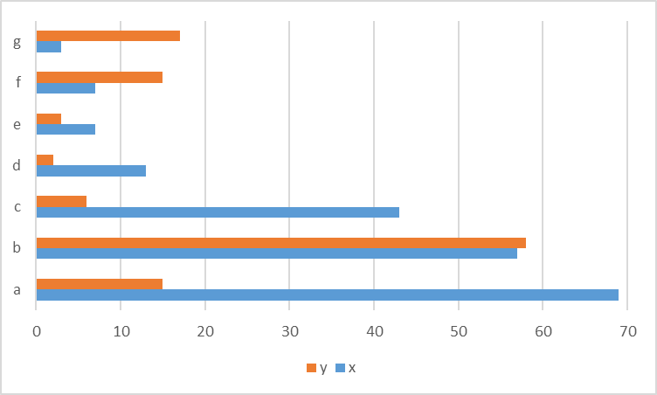

Heading | Heading | Heading
Row | Row | Row
Row | Row | Row
Table 1. Sample table for the abstract.

Key words:
Abstract, Template, Research, Sustainability, Energy (up to 5 words arranged in alphabetical order).
Acknowledgment: The authors would like to express appreciation for the support of the sponsors [Project Number = XXXXXXX]

